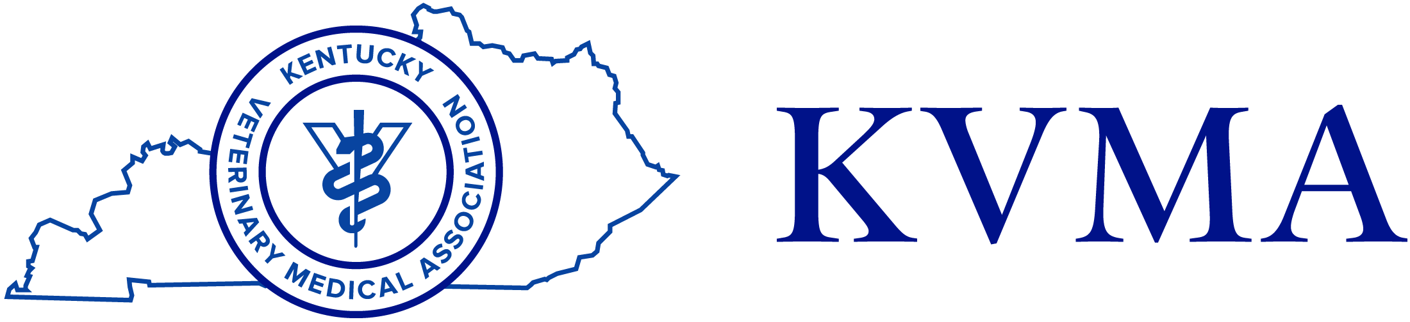
STAFF WANTED
Technician wanted: Needs experience and preferably with birds/exotics. Send resume to aviansam@gmail.com or call 502-245-7863 to schedule an appointment for an interview. Dr. Sam Vaughn (SP23)
Corydon, Indiana
Corydon Animal Hospital is looking for a full- or part-time veterinary technician to work in our well-established practice in Corydon, Indiana. Willing to offer extensive training and mentorship to technicians with limited experience. Please contact us for further information. Resumes can be emailed to dm.pelphrey@gmail.com (SP21)
If you would like to place a classified ad for a staff member and would like your name/clinic listed, please contact the KVMA at 502-552-5862 or e-mail info@kvma.org. Please keep your ad to 50 words or less.

